

Image classification

COS30082 – Applied Machine Learning



March 5, 2025

Name: hong anh nguyen

STUDENT ID: 104359382

# Methodology

In this section, the experience will flow from basic to advanced. The advanced methodologies such as augmentation data, transfer learning, systematic testing system…

***Overview of data collector:***

* The data first split physically to 2 folders (train and test) with ratio 9:1, the train folder further split to train and validation with ratio 8:2.
* Then these data were loaded using following method:

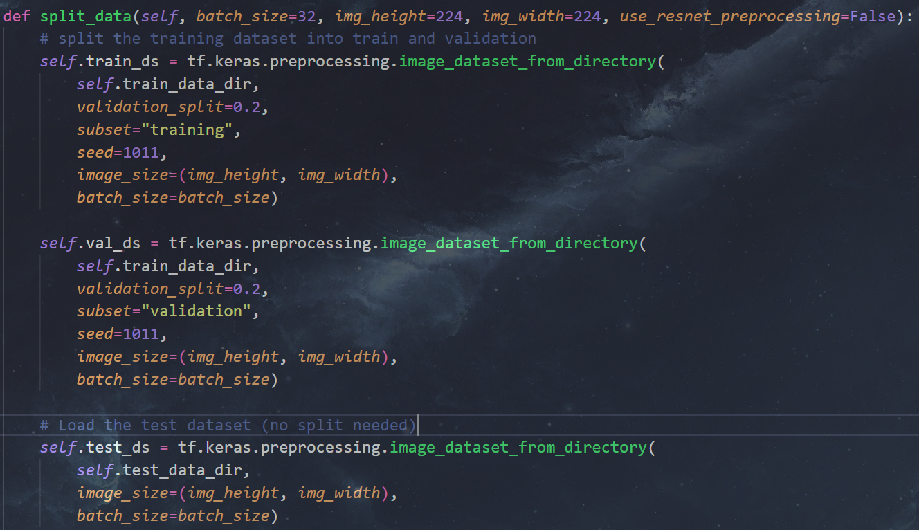

Figure 1. Loading and splitting Data

* Data augmentation setup:

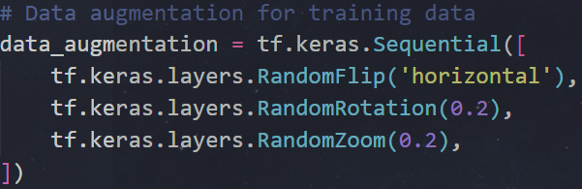

Figure 2. Data augmentation

* Preprocessing data (using normal standard normalization or using preprocessing method provided by ResNet), it is important to use resnet preprocessing when using resnet model, without that, the model may performance bad even the accuracy is high – from experience:

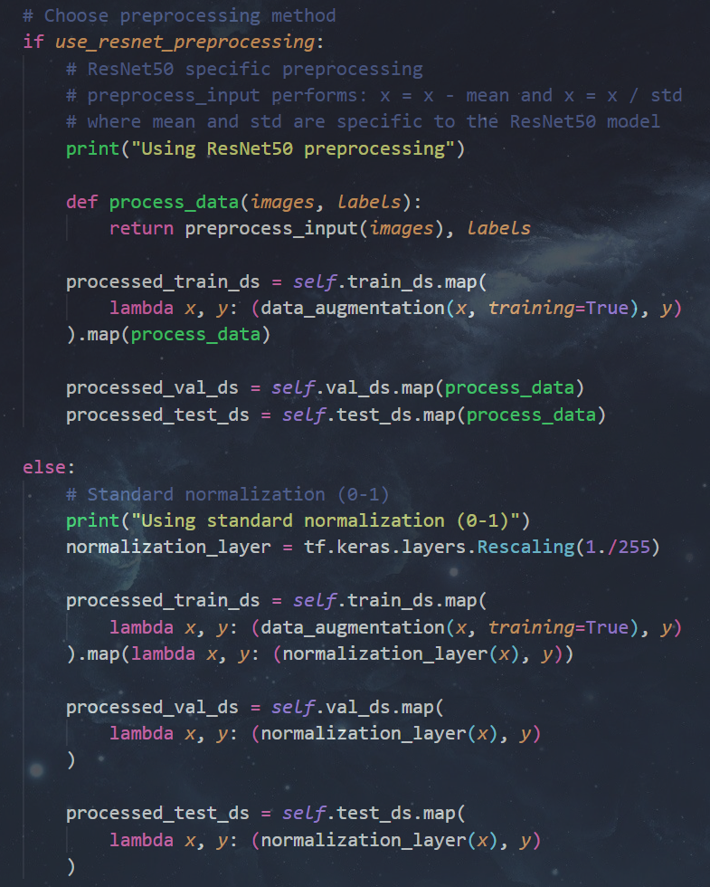

Figure 3. Preprocessing Data

* Finally, configuration the autotune for faster loading:

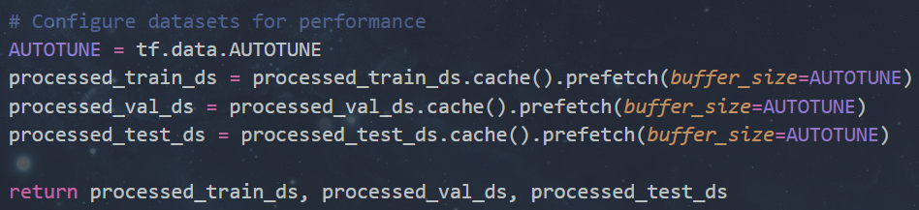

Figure 4. Autotune and return the datasets

***Overview of Training method:***

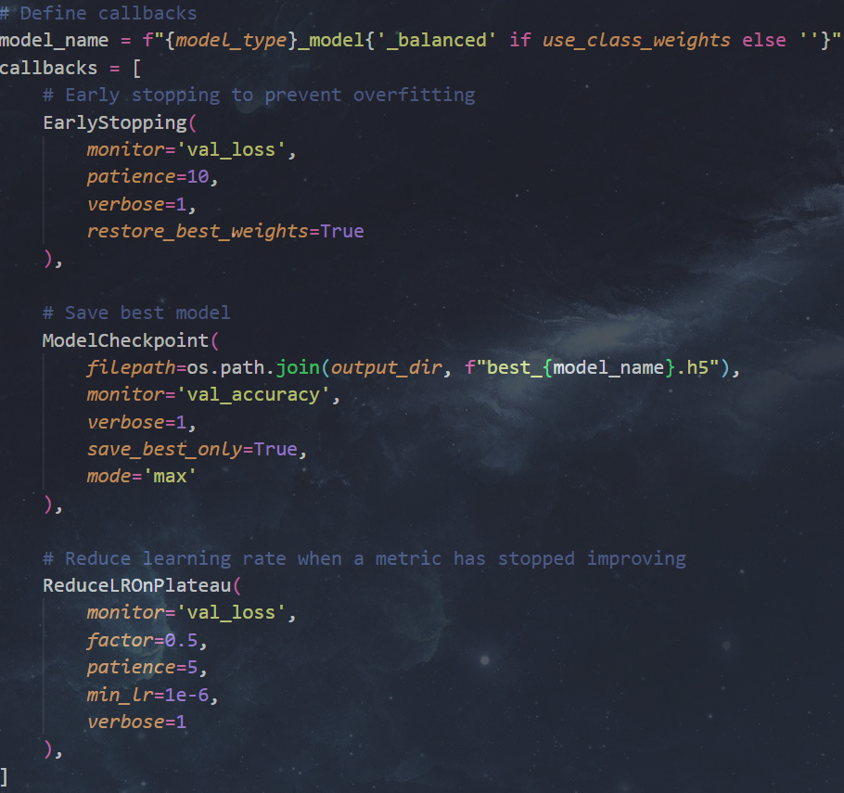

Figure 5. Callback constrains

* Early stopping with 10 epochs patient, Checkpoint for best model using validation accuracy and ReduceLROnPlateau learning rate scheduler were used. The reason for this scheduler is this is the most general strategy since if for certain epochs, no lower validation loss found then reduce the learning rate by a scaling factor. Since in this project, both pre-trained model and from scratch model were trained, using general scheduler will make it more convenient for the training process.
* A class weights strategy was implemented (since at first, I thought the dataset was imbalance but, it very balance 1000 images each class)

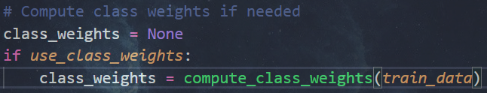

Figure 6. class weight calculates for weight training

* Optimizer using Adaldelta, loss using sparse categorical crossentropy and metric using accuracy. On this project, I trained model using local machine (Window Native) which only TensorFlow 2.10 and before support making some function like optimizer, metrics not up to date (Adam don’t have decay, and lack of some other methods which I planned to implement such as Label smoothing). After experimenting several optimizers such as Adam, SGD and Adadelta, the Adadelta showed the best performance with stable training.

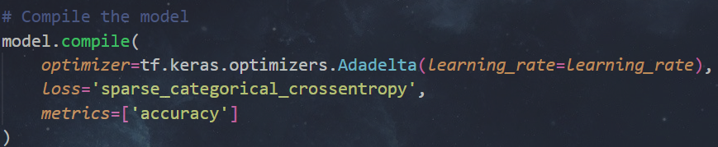

Figure 7. Training hyper-params

1. Basic CNN experience

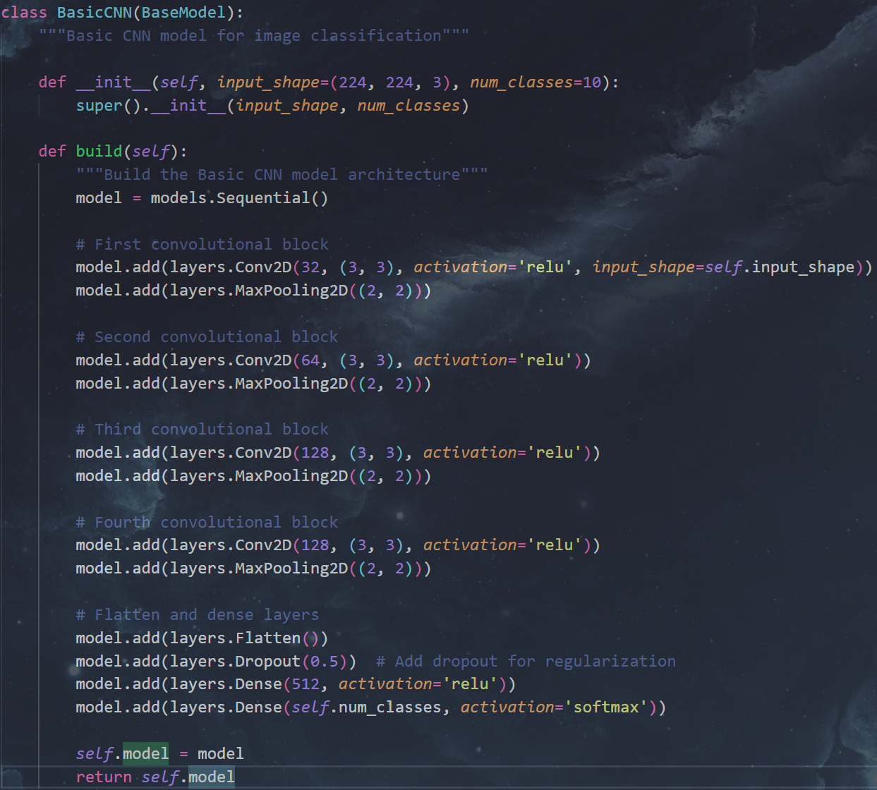

Figure 8. Basic CNN’s architecture

The basic CNN architecture was simply random initiated without reference to achieve some overview about the quality of the data (e.g. How is the diversity, quantity and quality).

1. Resnet50 from scratch:

After examining the history of training and evaluating result of basic CNN [figure 9], after the epoch 16, although the validation loss still decreased but validation accuracy didn’t decrease, while the training accuracy keep increased. This show that basic CNN can’t not capture (or learn) more information, or it will very slow, because of that, the Resnet50 model was implemented to provide a bigger model with more capabilities to learn and feature extract. Reason the from scratch version was also implemented instead of only pre-trained is for learning purposes.

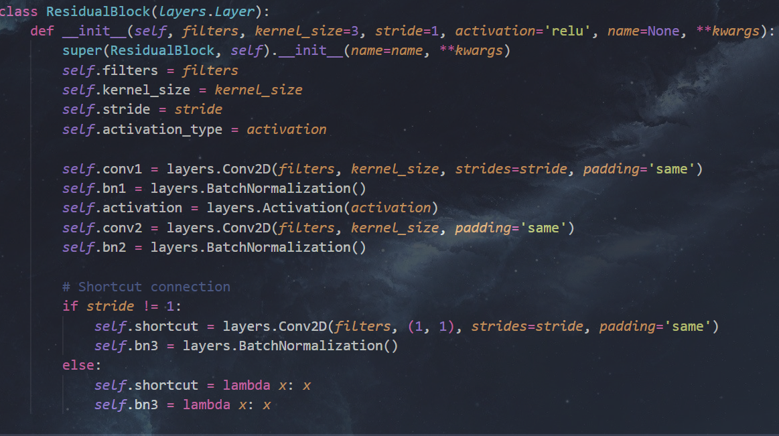

Figure 9. residual block for resnet50

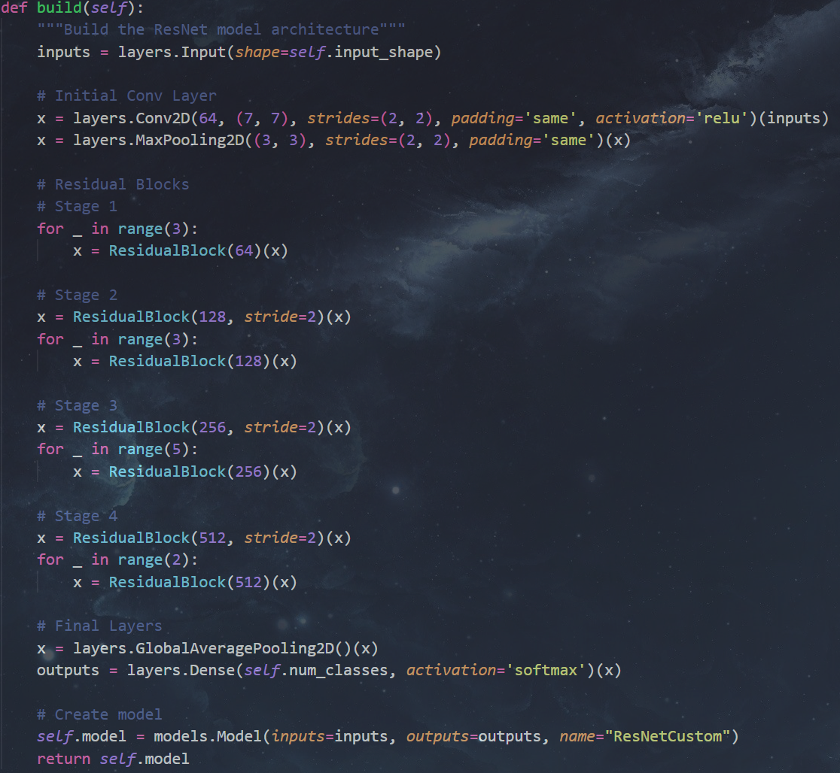

Figure 10. Entire model

After examining the history training and evaluating of this model, there are several issues:

* The time for training was significantly
* **Overfitting issue**

Many hypotheses about why the model occurs overfitting were made by experience:

* Lack of general knowledge leading to bias to some feature of current dataset (specific contrast, pose, light…)
* Hyper-parameters significantly sensitive since training from scratch normally requires the most optimized configuration of hyper-parameters and significantly large numbers of epoch.
* To overcome this, pre-trained ResNet50 was implemented as well as they pre-processing. Additionally, data augmentation was used to make dataset more general.

1. Resnet50 pre-trained:

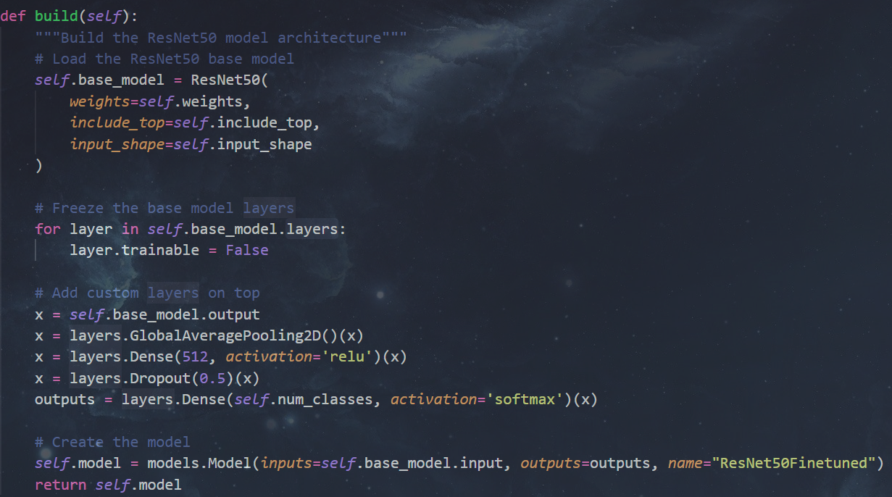

Figure 11. Initiating base model and add custom layers on top

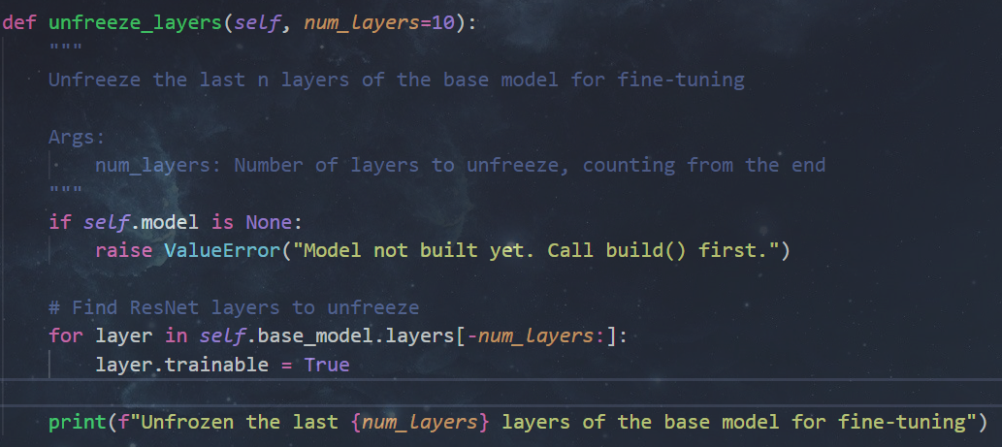

Figure 12. Unfreeze layer from top

This unfreezes certain numbers of layer make the model when fine-tune does not learn too much and too fast making them forget previous knowledge.

# Results and Discussion

* Basic CNN:
* 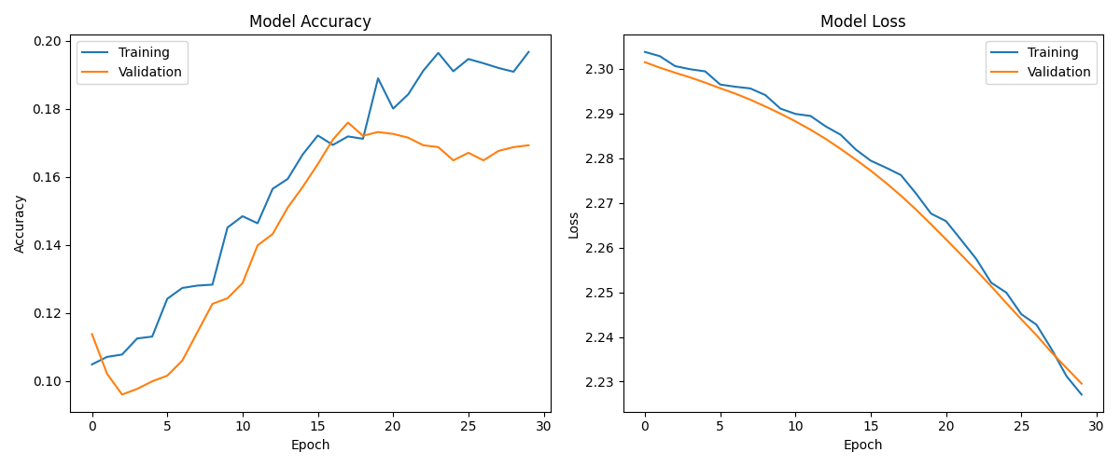
* Figure 13. Training and Evaluating History
* 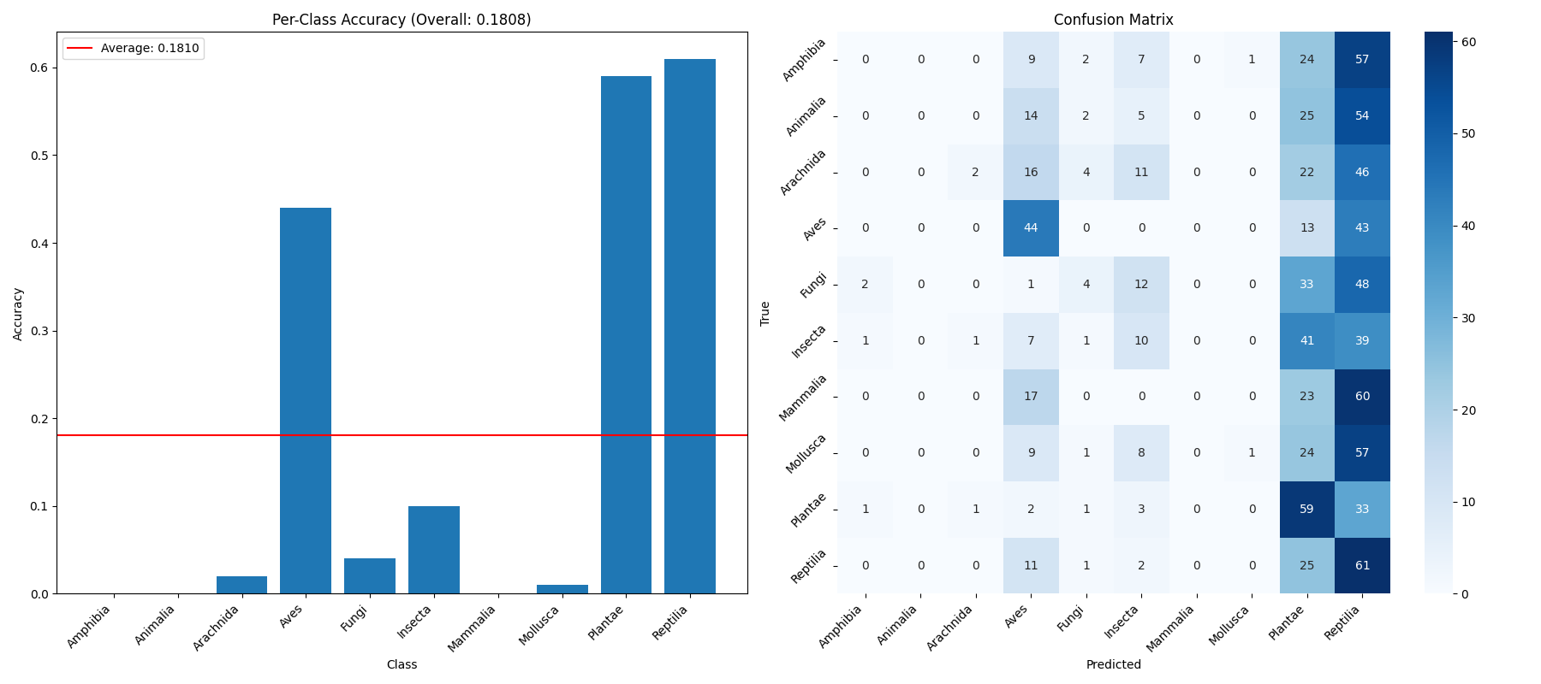
* Figure 14. Testing results – Basic CNN
* Resnet 50 from scratch:

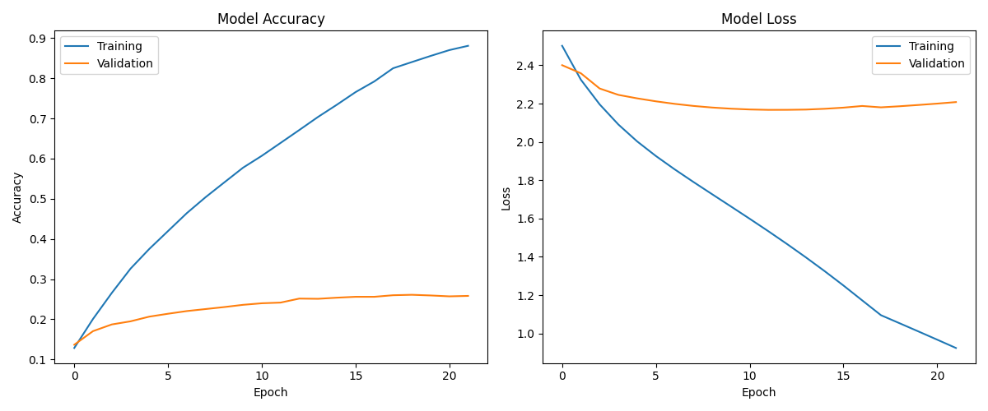

Figure 15. Training and Evaluating History

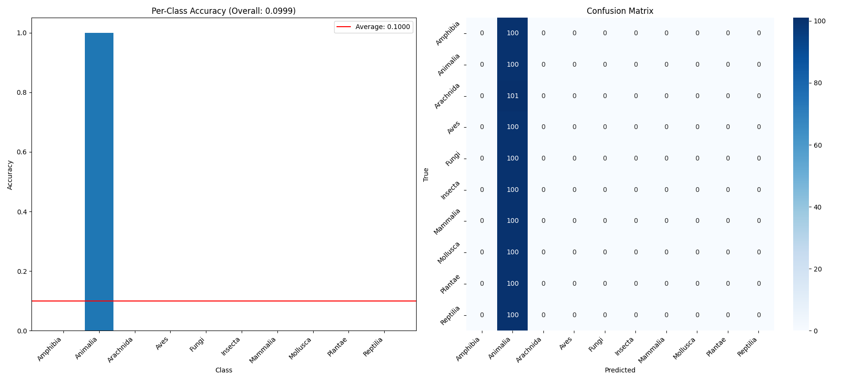

Figure 16. Testing result – ResNet50 from scratch

* Resnet 50 pre-trained, fine-tune with 20 layers unfreeze:

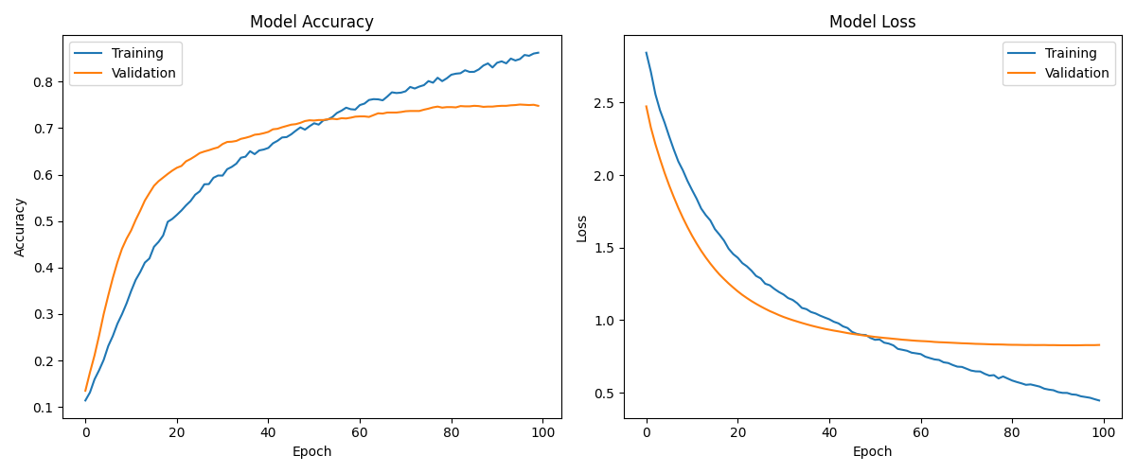

Figure 17. Training and Evaluating History

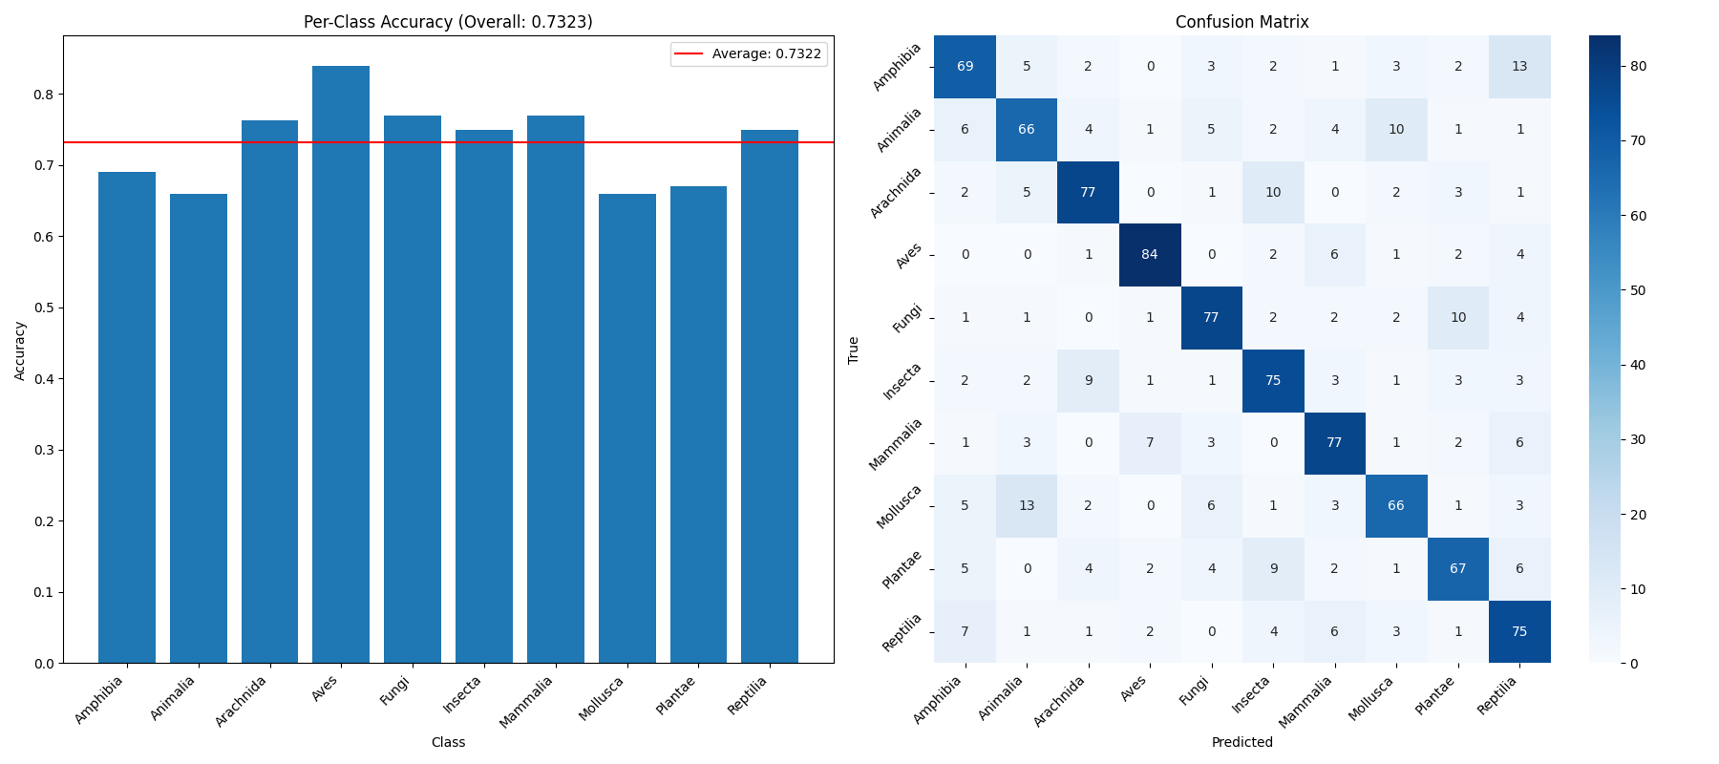

Figure 18. Testing result – Resnet50 fine-tuned

After justification of model selection in the previous section, we will further discuss about the performance of models. Note: Per-Class accuracy is **Top-1 Accuracy** and Average is Average **Accuracy per Class**.

While these first 2 models performed low performance, the fine-tuned version showed a huge improvement of accuracy which can reasonably since the quality and quantity of pre-knowledge they have from a proper training process.

Although the training and evaluating history of fine-tuned resnet50 shows us that model still can improve the performance but considering the time limit, only 100 epochs were used.

Inference new images example:

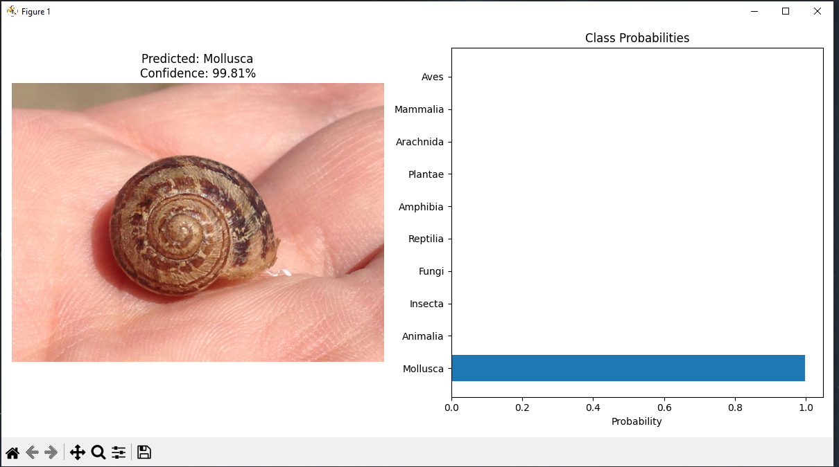

Figure 19. Ground truth – Mollusca

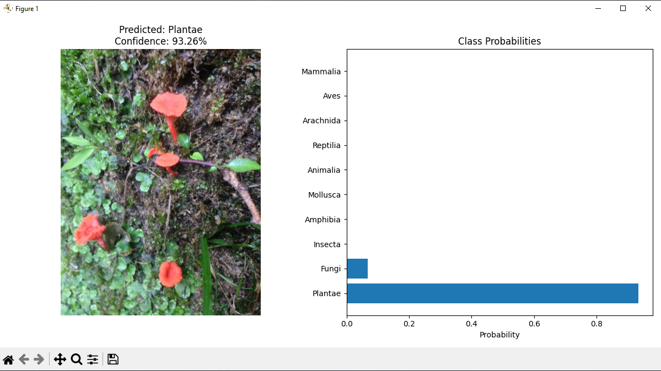

Figure 20. Ground truth – Fungi

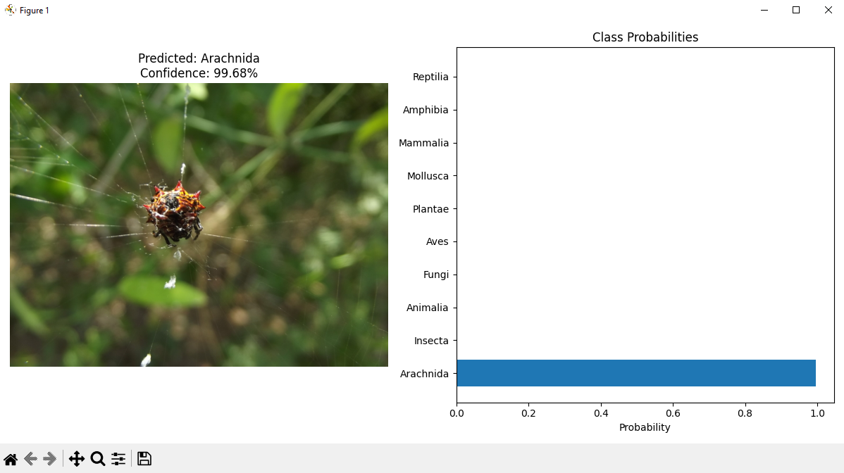

Figure 21. Ground truth – Arachnida

In conclusion, the fine-tuned process can be further improved if new techniques such as smoothing label, weighted optimizer… are available, but in general, fine-tuned is the most efficiency method since it utilize pre-trained knowledge and avoid the hyper-params tuning when pre-trained with large dataset.